
Fortinet Lightweight Access Point Configuration
By: Marvin Boonnantakul

Purpose: The purpose of this lab is to deploy a Lightweight Access Point inside the network through the FortiGate 40F firewall and the FortiAP (access point). To set up this lab Linux based FreeRADIUS server is required to provide a secure wireless connection through WPA2 Enterprise, which would allow users to connect wireless network through their individual username and password

Background Information on lab concepts: The key idea in this lab revolves around Lightweight Access Point, which comes from an access point that is directly managed by a central controller rather than being separately configured. The wireless controller in this case would be FortiGate 40F that would also manage the FortiAP. A setup like this provides network administrators an easier control over wireless devices in their network.
Additionally, to furthermore improve the wireless network’s security it would be ideal to implement FreeRADIUS server into the lab to provide Authetication, Authorization, Accounting (AAA). WPA2- Enterprise is used in the RADIUS protocol to verify user’s credentials making the network a lot more secure rather than a single sharable password. Through Linux acting as the host to configure the FreeRADIUS server, communication with FortiGate’s firewall can be achieved to authenticate wireless users/devices.

Lab Summary: By using a Linux machine, a FreeRadius server was installed and configured, to be used to test user accounts to make sure the communication status between the FortiGate firewall and the RADIUS server is successful.
Once communication is successful the RADIUS server is added on to the FortiGate 40F through the web GUI interface. Moreover, a enterprise wireless network was made in the bridge mode to configure on to the WPA2-Enterprise security with the RADIUS authentication.
The FortiAP was authorized and managed by the FortiGate wireless controller. This is crucial to the enterprise SSID when being assigned to the access point, and the configuration with the wireless settings. Finally, testing would confirm that users could successfully authenticate through the FreeRADIUS server and connect to the wireless network.
Problems:

Lab Commands: N/A

Configurations:

Network Diagram with IP’s:
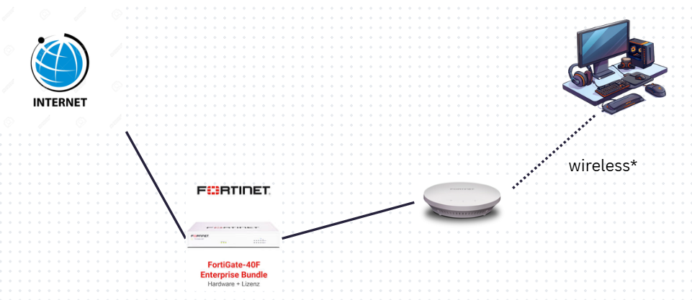

Conclusion: This lab clearly illustrates how FortiGate 40F firewall manages a Lightweight Access Point network with the use of Linux based FreeRADIUS server for a secure centralized authentication. The configuration uses WPA2-Enterprise to secure wireless access and individual user credentials.
Ultimately, this configuration highlights the centralized management and AAA services that can be used to create a secure wireless network that would also allow scalability through Linux administration, RADIUS configuration, enterprise wireless security and FortiGate wireless management.

Screenshots: 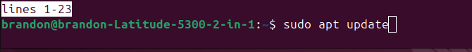
Updated the Linux packages before installing FreeRADIUS.

Installed the FreeRADIUS server and utility packages.
Boots FreeRADIUS from the files installed.
Enables FreeRADIUS to run
Entering into the client file to add the firewall’s IP
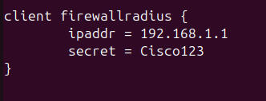
Added the firewall as a client and inputted the firewall’s ip to connect to it.
Entered the users file to add a test user
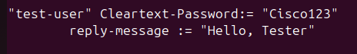
Creating the user in the file and giving a reply message to test if it works
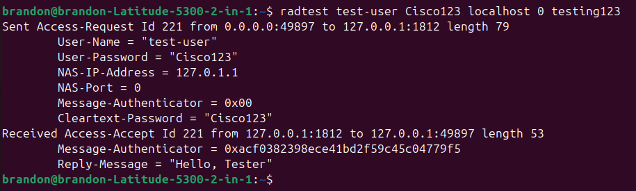
The reply message showed that the connection was successful.
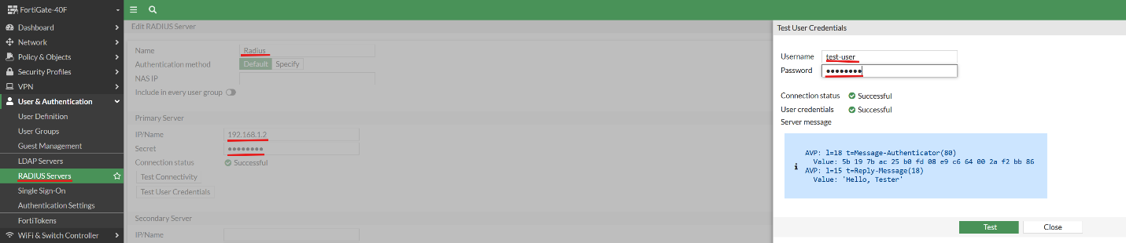
Connecting the RADIUS server to the firewall and successfully testing the connection.
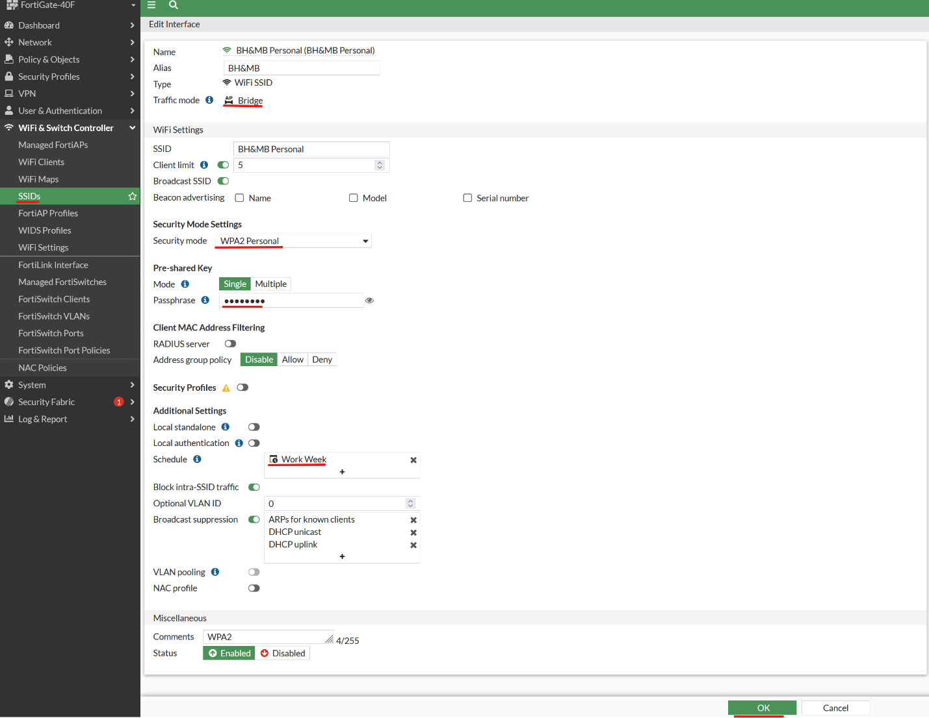
Setting up the SSID of the non-RADIUS server person, can connect with just the password.
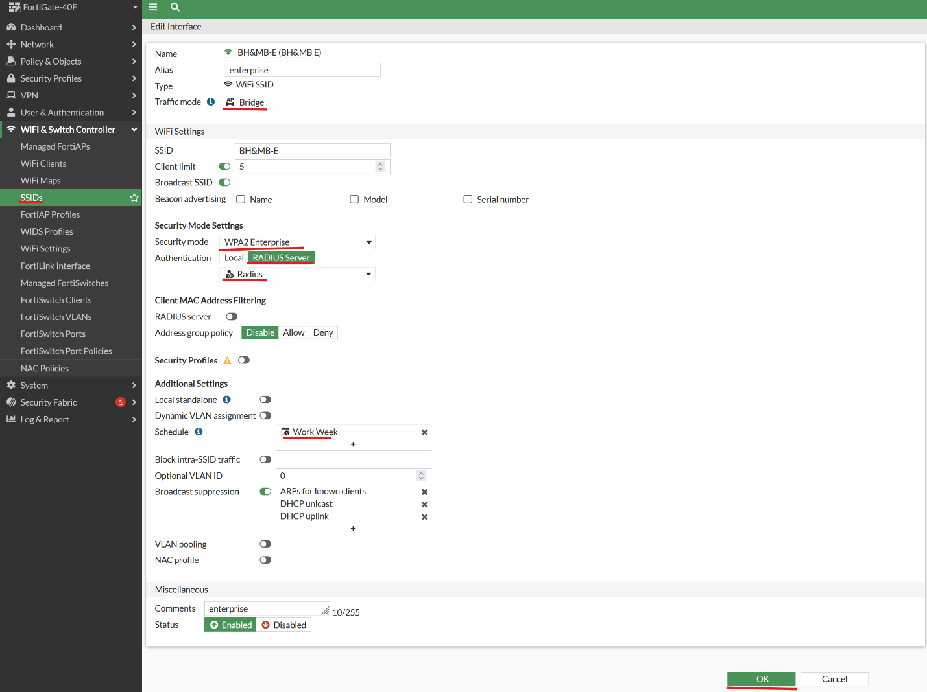
Using the RADIUS server in the users for enterprise security meaning needing a username and password to connect to the wifi
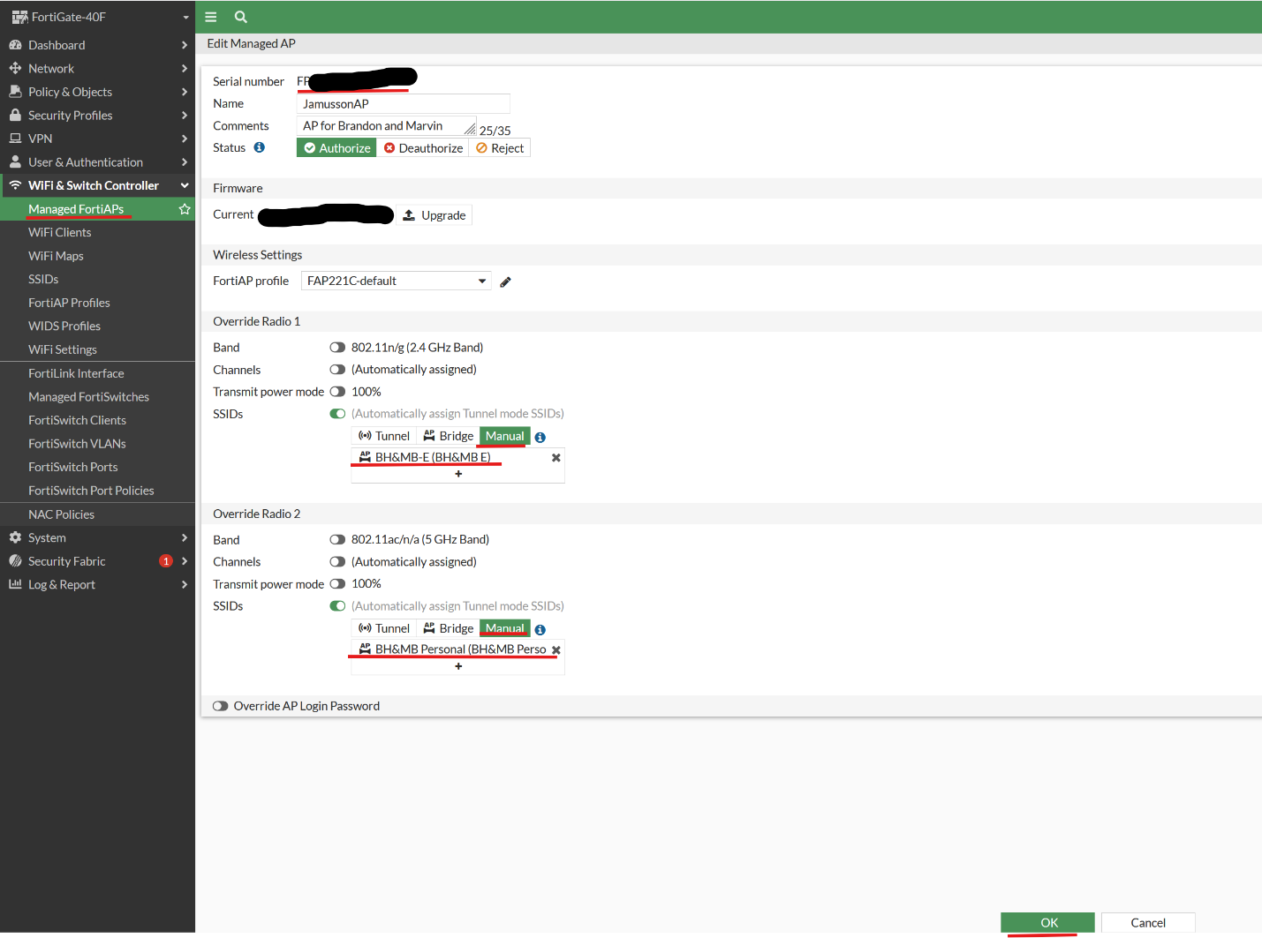
Added the AP as a extra device for it to be configured and managed by the firewall using the 2 SSIDs set up.

Sign off:
